Activity 4- Business Layer Patterns

Ryan Coon

CST-361

Professor Mark Smithers

June 5, 2022

Screenshots:

UML Class Diagram:

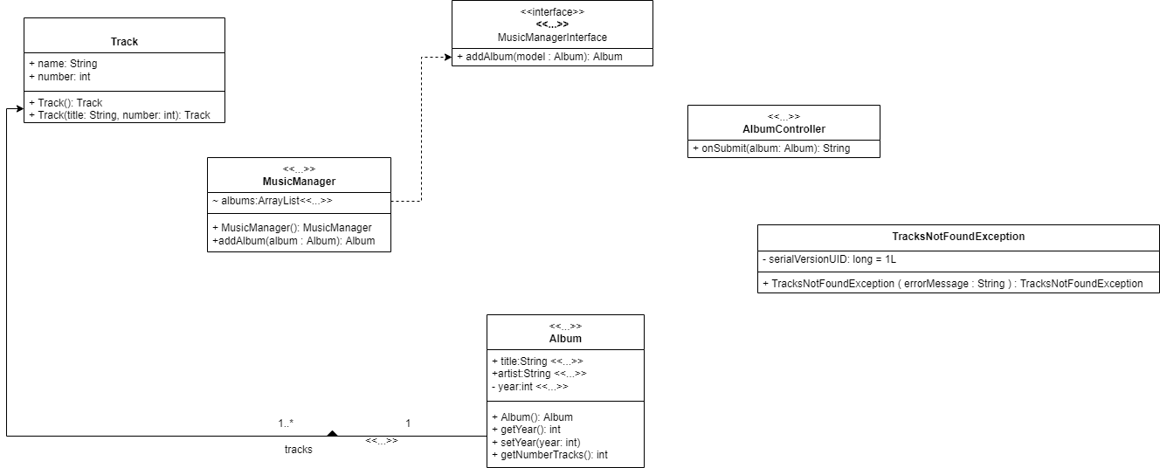

UML Sequence Diagram:

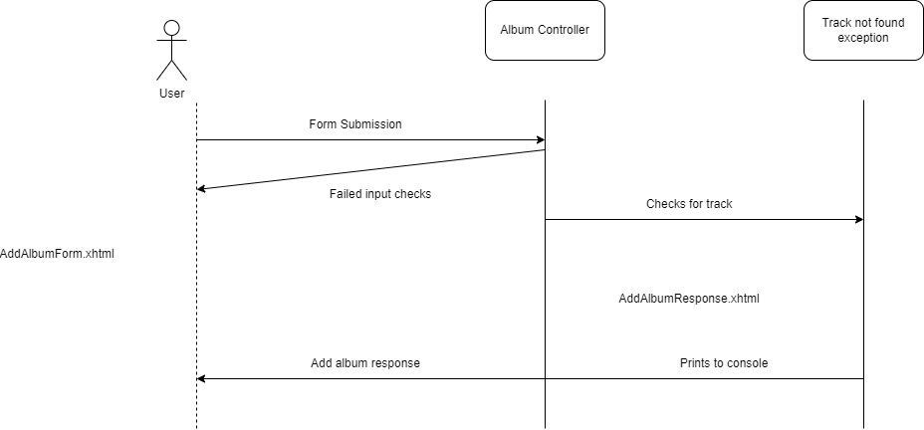

Façade Design Description:

The façade pattern is used to shield/ abstract the client from the business process. It hides the complexities of the system and provides an interface to the client. This pattern is a structural pattern as it adds an interface to an existing system to hide its complexities. This pattern involves a single class which provides simplified methods required by client and delegates calls to methods of existing system classes. The Façade pattern is often used when a system is very complex or difficult to understand because the system has a large number of interdependent classes, or its source code is unavailable. The pattern hides the complexities of the larger system and provides a simpler interface to the client. It typically involves a single wrapper class which contains a set of members required by client. These members access the system on behalf of the façade client and hide the implementation details.

As far as a previous program that I have done in these classes, I could not find the code for the one that came to mind. I believe it is on another computers hard drive that I can’t get into anymore. In the program we were instructed to make a race car to check tires and psi, engine, and body, then have that race car run a race. From what I remember this was a form of façade as the tires, engine and body ran out of their own class with the race that ran each of them.

References:

*Design patterns - facade pattern*. Tutorials Point. (n.d.). Retrieved June 4, 2022, from https://www.tutorialspoint.com/design_pattern/facade_pattern.htm